**Analyze data using Apache Spark**

**By**

**Israel Nolazco**

In this document there will be two exercises that will be conducted utilizing SPARK. The first exercise is going to do a word count function and the second exercise is going to us SparkSQL functions to further analyze statics gather by <http://www.seanlahman.com/baseball-archive/statistics/>

1. Word Count Function.

Having created our Microsoft Azure HDInsight with Spark, let us get started by first remotely logging into our VM.

Then we are going to create a sample text file. This file is going to the be the one we are executing our wordcount function into. To make this exercise a bit interesting, we use the first paragraph of the poem Phenomenal Woman by Maya Angelou which can be found here: <http://famouspoetsandpoems.com/poets/maya_angelou/poems/492>

Pretty women wonder where my secret lies.

I'm not cute or built to suit a fashion model's size

But when I start to tell them,

They think I'm telling lies.

I say,

It's in the reach of my arms

The span of my hips,

The stride of my step,

The curl of my lips.

I'm a woman

Phenomenally.

Phenomenal woman,

That's me.

After creating our text file, we are going to then move it to our /temp directory inside of the HDFS directory. Then we are starting our PYSPARK environment.

Having load pyspark there four lines of code that can create our word count function.

rdd = sc.textFile(“inputfile”)

rdd1 = rdd.flatMap(lambda line : line.split(‘ ’))

rdd2 = rdd1.map(lambda word: (word, 1))

rdd3 = rdd2.reduceByKey(lambda v1,v2: v1 + v2)

Further analyzing the lines of code, we can notice on the first line the “inputfile” is a reference point. Therefore, the location of our file must be clearly stated as we can see in the image below.

Note: pyspark does not automatically show the results of the commands being executed in out CLI. Therefore, in order to see the results of our execution the .collect() must be entered after the instance created. i.e rdd5 = blah blach. To get results rdd5.collect() is executed separately.

Additionally, I would like to point out the results we got. Based on the results, the word “my” appears five times, which can be a testament to the overall message of the poem.

1. SparkSQL

In this section of our exercises we are going to explore Spark SQL functions using pyspark. In the past we have shown sqlite3 in shell and in python. Previous experiences have shown us that querying with SQL in a python or shell environment is very unique. To start off, we first log into our HIVE environment and upload the People.csv table which was extracted from <http://www.seanlahman.com/baseball-archive/statistics/> Having this done, then technically speaking we should be able to confirm the presence of this table in our CLI environment with the following lines of code.

rdd = spark.sql(“show databases”).show()

and

rdd = spark.sql(“show tables”).show()

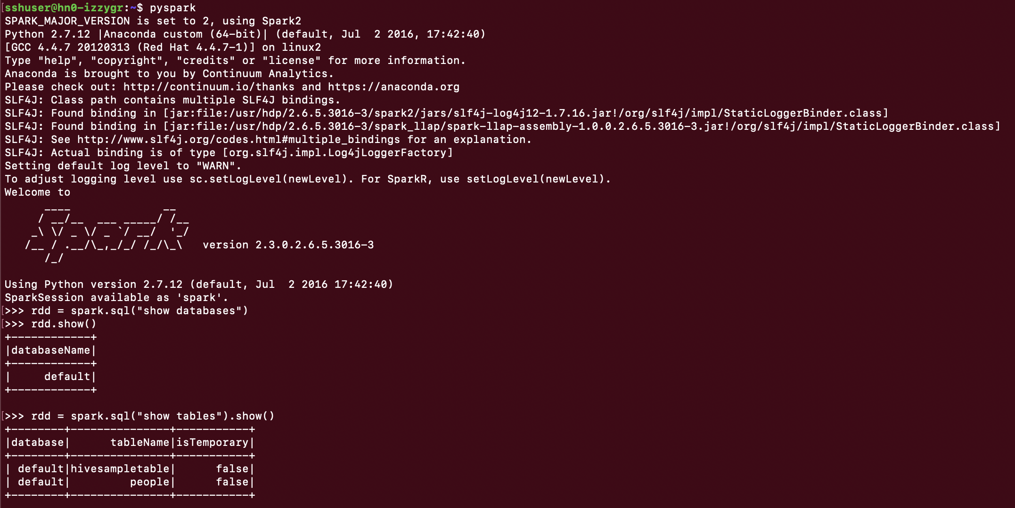

Note: take a notice of the structure of the code. The section of inside the parenthesis and quotations take the form of a regular SQL syntax format. Therefore, with this in mind we should be able to answer the following questions.

What is the total number of baseball players?

How many players were born before 1960?

How many players were born in or after 1960?

How many players were born outside of the USA?

How many players were born in the USA?

1. What is the total number of baseball players?

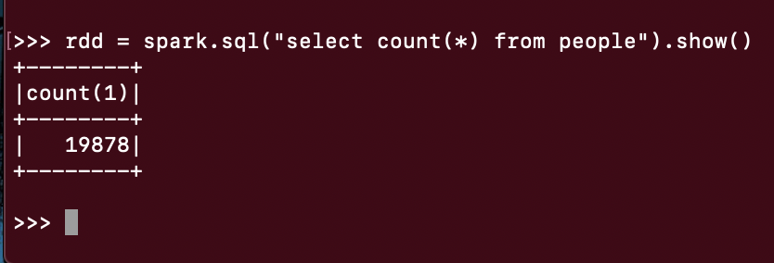

1. How many players were born before 1960?

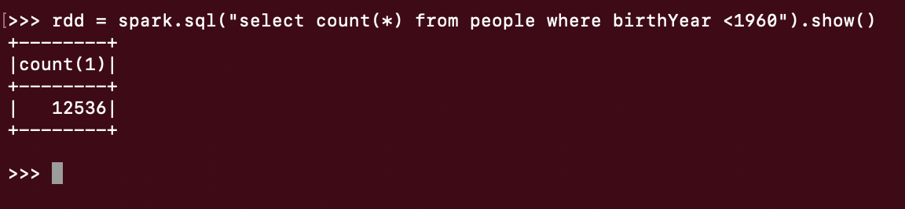

1. How many players were born in or after 1960?

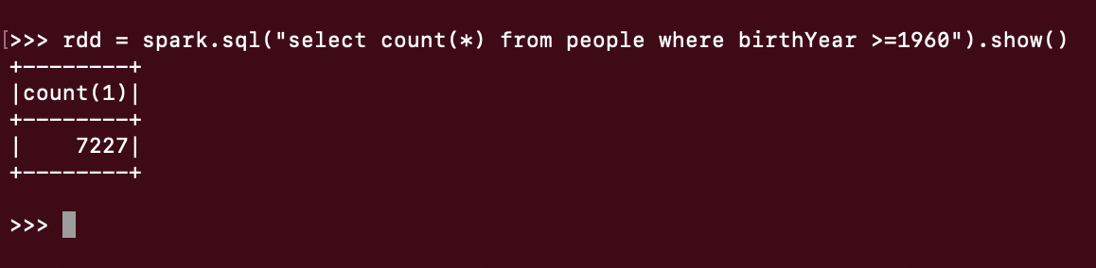

1. How many players were born outside of the USA?

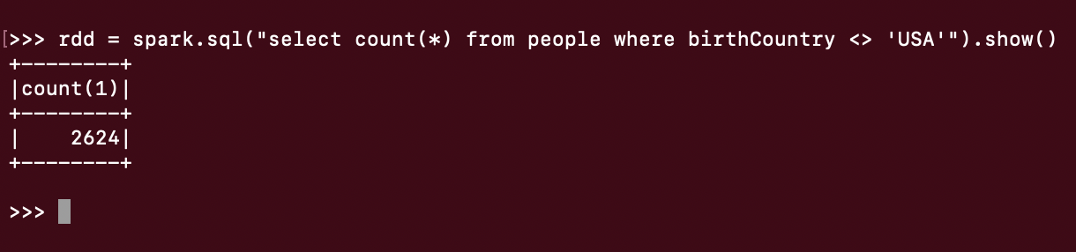

1. How many players were born in the USA?

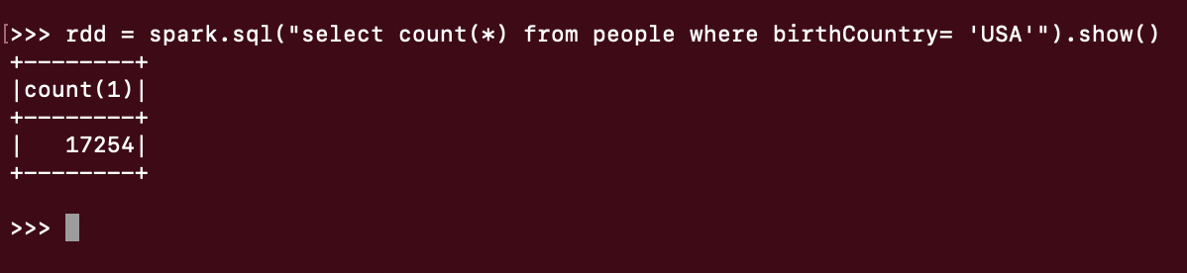

The results are presented in a neat and visually pleasing format. It is clear utilizing SPARK can be a very fexible tool. Instead of using a CLI, Jupyter or Zeppelin were also available option and those options have a different syntax. The bottom line is SPARK is fexible and adaptable to the user. The user could be a professional Linux user and use CLI continuously or a Software Engineer and only use Jupyter or simple self-taught programmer and use Zeppelin.